Marsh Junior High Elective Exploration
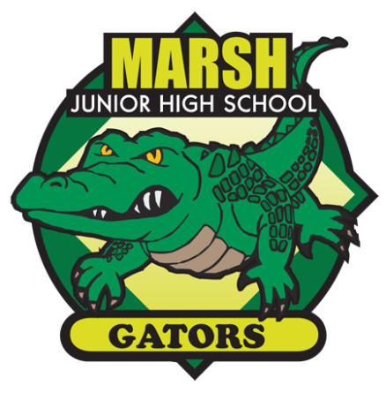
Marsh Jr. High students are fortunate to be exposed to a variety of elective courses. By the time students are in 8th grade, most students will have been placed in every elective (except for courses requiring teacher recommendations.) However, there are no guarantees of electives due to scheduling constraints.

How to Make Your Elective Course Requests at Marsh Junior High
Incoming 6th Grade Students – 2022/23 School Year

- Log into your Aeries Parent/Student Portal account. Be sure you go to Change Student and select your student’s name PRE-ENROLLED – Grd 6 – Marsh.
- Go to Classes choosing “Course Requests Entry” from the dropdown menu and click the search button for “Show all Courses” box.
- Click the course you prefer as your 1st choice. A box will appear near the top of the screen verifying the request. Click OK. Then click “Add Alternate” to choose your 2nd choice.
Please DO NOT add more than one alternate choice as more than two (2) choices affects your preferences.

COURSE ID # | TITLE | COURSE DESCRIPTION | GRADES
11010 | Art  Semester class | This introductory course is filled with projects for the beginning art student. We will be creating art projects such as Scratch Art, Kaleidoscope Names, Mixed Media Pastel and Pen drawings, Pencil and Smudge stick, just to name a few. | 6, 7, 8
11030 | Beginning Band  Year-long class | Do you want to learn how to play an instrument? If so, Beginning Band is for you. Pick your choice of a woodwind instrument (flute, clarinet, saxophone), a brass instrument (trumpet, horn, trombone, baritone), or percussion (drums, mallets and piano). As you learn your instrument, you’ll get plenty of opportunities to perform on the Marsh campus as well as on field trips to the high schools, Chico State, and elsewhere. If you like performing, this class is for you. For students with no experience or one year of elementary band. | 6, 7, 8
11080 | Drumming  Semester class | Have you ever wanted to rock out on the drums? This is your chance. This course is designed to introduce students to the world of drumming. Students will be playing drums, buckets, and all other sorts of percussion equipment. Students will learn to read and write music and will even form their own band! | 6, 7, 8  Class may be repeated if desired
11050 | Chorus  Year-long class | Do you love to sing? Then Chorus is for you! This class is a beginning to intermediate level chorus designed to introduce music reading, the fundamentals of singing, breathing, two to three part choral singing and working together as a group. Music reading, interval listening, dictation and proper group singing are emphasized. | 6, 7, 8
COURSE ID # | TITLE | COURSE DESCRIPTION | GRADES
11090 | STEM - Makerspace  Semester class | This course will provide an introduction to the tools, materials, and maker culture associated with Makerspace, where students develop creative solutions to real world challenges through tinkering, exploring, and inventing. Students will learn design thinking (3D sketching and modeling) and explore making with both “bits” (physical materials) and “bytes” (digital materials). Units may include 3D printing, circuitry, animation, toy making and more! | 6, 7
19180 | Computers  Semester class | This introductory class is a semester packed with a variety of computer experiences focusing on Google Applications, an introduction to coding, and so much more! Students will also learn about computer components as well as about online safety. | 6. 7, 8
19306 | AVID 6 – Avid Philosophy  Year-long class | The sixth grade AVID Elective course is an introduction to the AVID philosophy. Students will develop awareness of the values accompanying academic goals and success. The course will focus on building self-confidence and communication skills in working with peers and adults. Students will be exposed to reading strategies that will assist in vocabulary building and understanding a variety of texts, and will also focus on prewriting techniques, summary writing and structural components of note-taking. The students will increase college and career awareness through guest speaker presentations, field trip opportunities and research. | 6
19081 | Leadership/ Student Government  Semester class | Is there a leader within you? Do you want to be in charge of school activities? If you answered “YES,” Leadership/Student Government is for you! Future 6th graders: Applications are through your 5th grade teachers and the deadline is April 29th. Questions? Email Ryan Willard at rwillard@chicousd.org. | 6, 7, 8  Application required
19080 | Publications  Year-long class | This year-long class will focus on producing the MJHS Yearbook. Graphic design and photography are a large part of this class. Students must be willing to take pictures at a variety of school events and take responsibility for their assigned portion of the yearbook. Other published projects may be produced throughout the year. | 6, 7, 8  Teacher approval

